Christopher A. Coons 87 Reads Way
County Executive New Castle, DE 19720

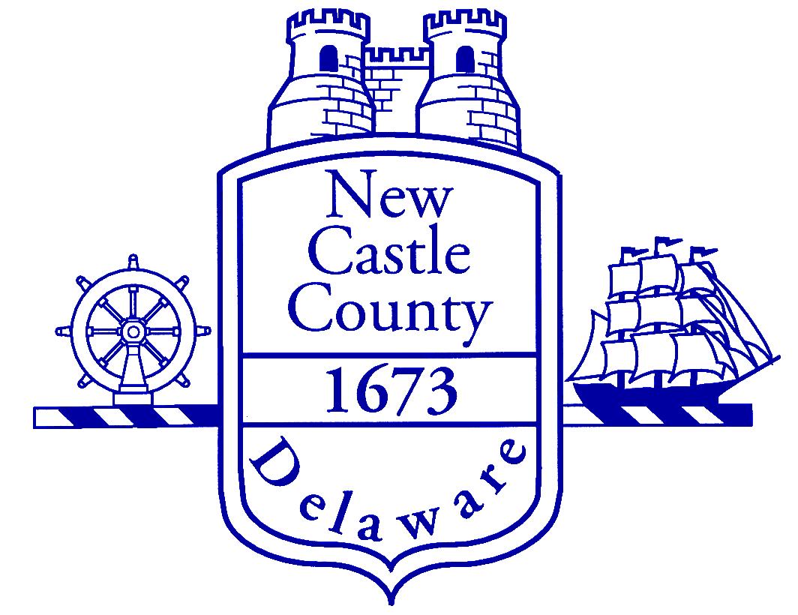
October 10, 2008

Dear LiberalGeek:

I have heard from many county residents recently who are concerned about current and future development plans in their area that include workforce housing. I want you to know that I and my administration take these concerns seriously, and we are working with County Council and state officials to review the workforce housing ordinance in order to ensure it does not have a negative impact upon existing communities.

There has been a great deal of misinformation spread about the county’s workforce housing ordinance. Many concerns have been raised about the impact of this ordinance on schools and roads and the process by which plans are approved. Before any new development is approved in New Castle County, all development plans must be reviewed by relevant state agencies, including DelDOT and the state Department of Education (DOE), to ensure the local roads and schools can accommodate the planned growth. Without their approval, plans may not move forward in our process unless conditions set forth by DelDOT and DOE are met.

My administration and County Council are working together to review the workforce housing section of the Unified Development Code (UDC) to determine if adjustments should be made. In conducting this review, we are asking for public input.

On Wednesday, October 22, 2008 from 6:30 p.m.- 8:30 p.m. in the Gilliam Building located at 77 Reads Way in New Castle, we will hold an informational meeting for the public in which the Departments of Land Use and Community Services will give an informational overview of the workforce housing ordinance and our process for working with state agencies. We believe this will be an excellent opportunity for the public to receive an overview of the ordinance, ask questions and make comments and suggestions.

In addition to the meeting, starting Monday, October 13, 2008, the public will be allowed to submit any comments, suggested changes and/or questions they may have on workforce housing to us through the email LandUse@nccde.org.

Thank you again for your letter, and please feel free to contact my office at 302-395-5101 if I can be of further assistance.

Yours,

Christopher A. Coons
New Castle County Executive

